Lambert function and quadratic summation for numbers from 1:N

$$COS\left(W\left(f\left(X\right)\right)\right)=-1 for x=-0.5+0.5\sqrt{1+8*LambertW(π)}$$

Quadratic summation function from last article is

$$\sum_{0}^{X}{X}=\left(\frac{1}{2}+\frac{X}{2}\right)*X$$

The value of the summation of all numbers from 1 up until N; is the intersection point between this quadratic summation function and its identical function f(x).

$f\left(X\right)=W*X$

where $W=\left(\frac{1}{2}+\frac{X}{2}\right)$, w is slope of linear function where X/2=N or N=X/2.

For example: - If we want to get the sum of all numbers from 1 up until N =X= 17, then our function will be = 153.

$f\left(X\right)=\left(\frac{1}{2}+\frac{X}{2}\right)*X= \left(\frac{1}{2}+\frac{N}{2}\right)*X=\left(\frac{1}{2}+\frac{17}{2}\right)*X=\left(\frac{1}{2}+\frac{17}{2}\right)*17$

$f\left(X\right)=\left(\frac{1}{2}+\frac{X}{2}\right)*X=\left(\frac{1}{2}+\frac{17}{2}\right)*X=9*X$

Now let us do this, write Lambert function using this f(X)

$$W\left(f(X)\right)={f\left(x\right)* e}^{f(x)}=\left(\frac{1}{2}+\frac{X}{2}\right)*X*e^{\left(\frac{1}{2}+\frac{X}{2}\right)*X}$$

Now get SIN for this Lambert function

$$Sin\left(W\left(f\left(X\right)\right)\right)=Sin( \left(\frac{1}{2}+\frac{X}{2}\right)*X*e^{\left(\frac{1}{2}+\frac{X}{2}\right)*X} )$$

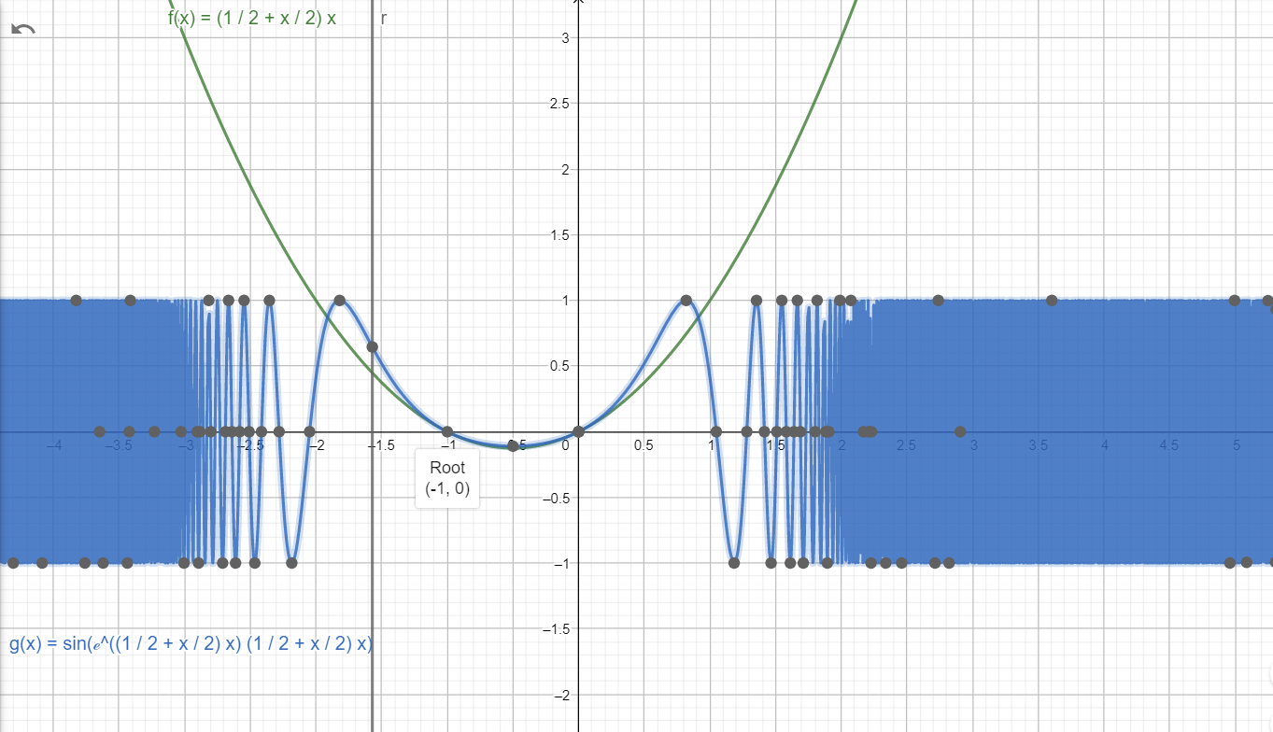

What is nice about this transformation is

1. It has root at point (-1, 0)

$Sin\left(W\left(f\left(X\right)\right)\right)=0 for x=0$

$Sin\left(W\left(f\left(X\right)\right)\right)=1 for x=-0.5+0.5\sqrt{1+8*LambertW(\frac{π}{2})}$

$Sin\left(W\left(f\left(X\right)\right)\right)=-1 for x=-0.5+0.5 \sqrt{1+8*LambertW(\frac{3π}{2})}$

Now get COS for this Lambert function

$$COS\left(W\left(f\left(X\right)\right)\right)=COS( \left(\frac{1}{2}+\frac{X}{2}\right)*X*e^{\left(\frac{1}{2}+\frac{X}{2}\right)*X} )$$

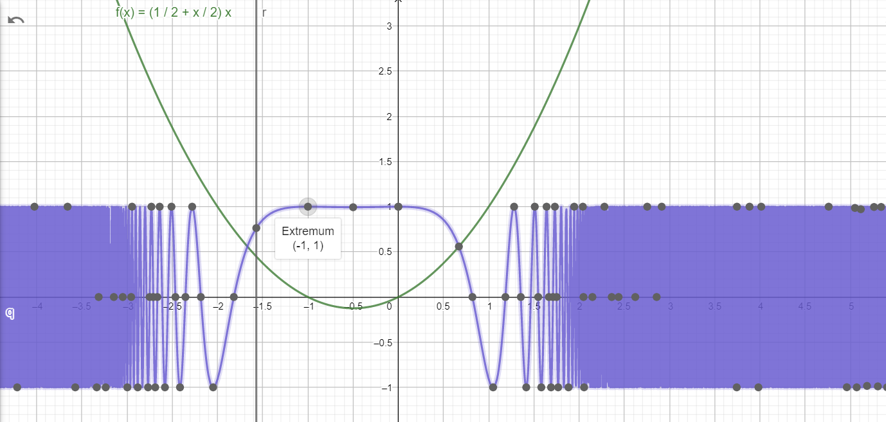

What is nice about this transformation is

1. It has extremum at point (-1, 1)

$COS\left(W\left(f\left(X\right)\right)\right)=1 for x=0$

$COS\left(W\left(f\left(X\right)\right)\right)=-1 for x=-0.5+0.5\sqrt{1+8*LambertW(π)}$

$COS\left(W\left(f\left(X\right)\right)\right)=1 for x=-0.5+0.5 \sqrt{1+8*LambertW(2π)}$

And this two transformations SIN and COS intersects at $\frac{1}{\sqrt{2}}$

